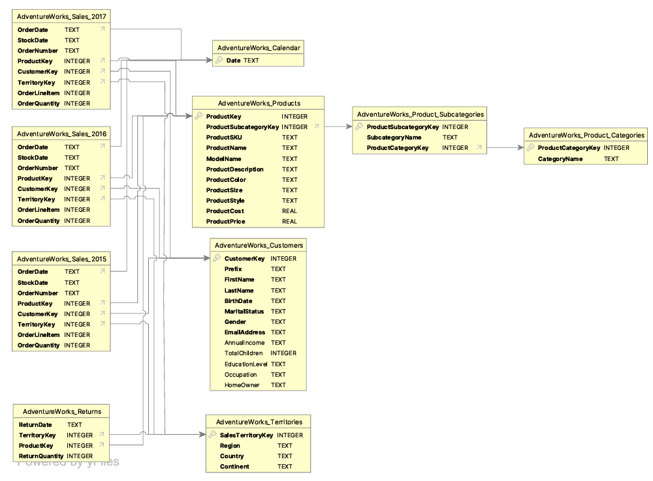

**DATA SCHEMA PROCEDURES**

Pertaining the report for the data star schema shown in the uploaded image, these are the key procedures required for building the star schema in SQL and ensuring data cleanliness.

1. **Understanding the Schema**

From the uploaded image, the star schema revolves around sales data from three years (2015, 2016, 2017), with customers, products, territories, and returns serving as dimensions. There is also a calendar table that connects the sales data by date.

**The central fact tables are:**

AdventureWorks_Sales_2015

AdventureWorks_Sales_2016

AdventureWorks_Sales_2017

AdventureWorks_Returns

**The dimension tables are:**

AdventureWorks_Products

AdventureWorks_Customers

AdventureWorks_Territories

AdventureWorks_Product_Subcategories

AdventureWorks_Product_Categories

AdventureWorks_Calendar

2. **SQL Scripts to Build the Star Schema**

Step 1: Create Dimension Tables

Products Dimension

CREATE TABLE AdventureWorks_Products (

ProductKey INTEGER PRIMARY KEY,

ProductSubcategoryKey INTEGER,

ProductSKU TEXT,

ProductName TEXT,

ModelName TEXT,

ProductDescription TEXT,

ProductColor TEXT,

ProductSize TEXT,

ProductCost REAL,

ProductPrice REAL

);

Customers Dimension

CREATE TABLE AdventureWorks_Customers (

CustomerKey INTEGER PRIMARY KEY,

Prefix TEXT,

FirstName TEXT,

LastName TEXT,

BirthDate TEXT,

MaritalStatus TEXT,

Gender TEXT,

EmailAddress TEXT,

AnnualIncome REAL,

TotalChildren INTEGER,

EducationLevel TEXT,

Occupation TEXT,

HomeOwner TEXT

);

Territories Dimension

CREATE TABLE AdventureWorks_Territories (

SalesTerritoryKey INTEGER PRIMARY KEY,

Region TEXT,

Country TEXT,

TerritoryGroup TEXT

);

Product Subcategories Dimension

CREATE TABLE AdventureWorks_Product_Subcategories (

ProductSubcategoryKey INTEGER PRIMARY KEY,

SubcategoryName TEXT,

ProductCategoryKey INTEGER

);

Product Categories Dimension

CREATE TABLE AdventureWorks_Product_Categories (

ProductCategoryKey INTEGER PRIMARY KEY,

CategoryName TEXT

);

Calendar Dimension

CREATE TABLE AdventureWorks_Calendar (

Date TEXT PRIMARY KEY

);

Step 2: Creating Fact Tables

Sales Fact Table

CREATE TABLE AdventureWorks_Sales_2015 (

OrderDate TEXT,

StockDate TEXT,

OrderNumber TEXT,

ProductKey INTEGER,

CustomerKey INTEGER,

TerritoryKey INTEGER,

OrderLineItem INTEGER,

OrderQuantity INTEGER,

FOREIGN KEY (ProductKey) REFERENCES AdventureWorks_Products(ProductKey),

FOREIGN KEY (CustomerKey) REFERENCES AdventureWorks_Customers(CustomerKey),

FOREIGN KEY (TerritoryKey) REFERENCES AdventureWorks_Territories(SalesTerritoryKey)

);

The same applies for AdventureWorks_Sales_2016 and AdventureWorks_Sales_2017.

Returns Fact Table

CREATE TABLE AdventureWorks_Returns (

ReturnDate TEXT,

ProductKey INTEGER,

CustomerKey INTEGER,

TerritoryKey INTEGER,

ReturnQuantity INTEGER,

FOREIGN KEY (ProductKey) REFERENCES AdventureWorks_Products(ProductKey),

FOREIGN KEY (CustomerKey) REFERENCES AdventureWorks_Customers(CustomerKey),

FOREIGN KEY (TerritoryKey) REFERENCES AdventureWorks_Territories(SalesTerritoryKey)

);

**3. Data Cleaning Procedures**

Cleaning the data is crucial to ensure that the data is in the right format, free from duplicates, and correctly linked. Here are some SQLbased data cleaning steps:

Step 1: Removed NULLs and replaced with NA in the prefix column at the AdventureWorks_Customers table.

Step 2: Fill in Missing Dates

Ensure that the Calendar table contains all the dates found in the OrderDate fields:

Insert missing dates from the sales data into the Calendar table

INSERT INTO AdventureWorks_Calendar (Date)

SELECT DISTINCT OrderDate FROM AdventureWorks_Sales_2015

WHERE OrderDate NOT IN (SELECT Date FROM AdventureWorks_Calendar);

Step 3: Normalize Text Fields

Standardize inconsistent text data for uniformity and also updating the values in the database from abbreviated forms to full forms which helps make the data more readable and consistent.

UPDATE AdventureWorks_Customers

SET Gender = REPLACE(REPLACE(Gender, 'M', 'Male'), 'F', 'Female');

UPDATE AdventureWorks_Customers

SET MaritalStatus = REPLACE(REPLACE(MaritalStatus, 'M', 'Married'), 'S', 'Single');

UPDATE AdventureWorks_Customers

SET HomeOwner = REPLACE(REPLACE(HomeOwner, 'Y', 'Yes'), 'N', 'No');

UPDATE AdventureWorks_Customers

SET FirstName = UPPER(FirstName), LastName = UPPER(LastName);

Step 4: Text Cleaning: This involves identifying and correcting (or removing) corrupt or inaccurate records from a dataset. In your case, it's about removing invalid characters (e.g., �) from the FirstName, LastName and emailaddress fields in the SQLite database.

UPDATE AdventureWorks_Customers

SET FirstName = REPLACE(FirstName, '�', ''),

LastName = REPLACE(LastName, '�', '')

WHERE FirstName LIKE '%�%' OR LastName LIKE '%�%';

UPDATE AdventureWorks_Customers

SET EmailAddress = REPLACE(EmailAddress, '�', '')

WHERE EmailAddress LIKE '%�%';

Conclusion

This report provides the SQL scripts and data cleaning steps necessary to create and maintain a star schema as per the database structure shown in the image. Following these procedures ensures reproducibility and data integrity for transparent analysis. Each of the SQL queries addresses core aspects of the sales and returns data while ensuring that the dimensions like customers and products are correctly maintained.